Ace Center
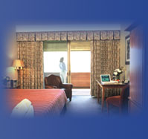
800 Ridge Pike (Ridge Pike and Manor Road)
Lafayette Hill, PA 19444
Toll-Free: (800) 523-3000
Phone: (610) 825-8000
Fax: (610) 940-4343
Website: http://www.aceconferencecenter.com
E-Mail: susan.mahoney@ace-ina.com

Guests at ACE Center enjoy spacious and comfortable accommodations. 120 distinctive guest rooms are available, including 3 parlor suites, 80 double queen rooms, 25 with single king beds, and 6 fully-accessible rooms with single queen beds.
Care has been taken to separate the living quarters from the meeting rooms and recreation facilities, to ensure privacy and peaceful refuge for our guests. Each room includes a marble-tiled bathroom, fine furnishings and many personal amenities selected to help our guests feel at home, especially those guests who stay for several weeks while participating in intense training or management development programs. There is also an outdoor balcony or patio for every room providing splendid views of the golf course or beautifully-landscaped courtyard.
Other features include:
Work space designed into every room including a desk, ample lighting, dual-line, cordless telephones, fax/computer data ports, High-Speed Internet Access, and comfortable seating.
Color cable TV w/stereo and on demand movies
Clock radio
CD player
Closet with full-length mirror, iron & ironing board.
Hair dryer, lighted make-up mirror and a complete amenity package with terry bathrobe.
Coffee maker
State-of-the-art security systems with electronic locks and audio and visual fire alarms. Security personnel on duty 24 hours.
Some rooms also offer leather recliners with reading lamps and mini-refrigerators. Parlor suites have wet bars with refrigerators. You will find all of the ambiance and amenities essential for comfort, relaxation and renewal.
ACE Center is centrally located: about halfway between Valley Forge National Park and historic Philadelphia; and about halfway between Washington, D.C. and New York City. It is easily accessible by car from I-276, I-76 and I-476, as well as by train and plane. By corporate jet or plane, Wing’s Field is only 15 minutes away. A private helipad also is available right at our front door!
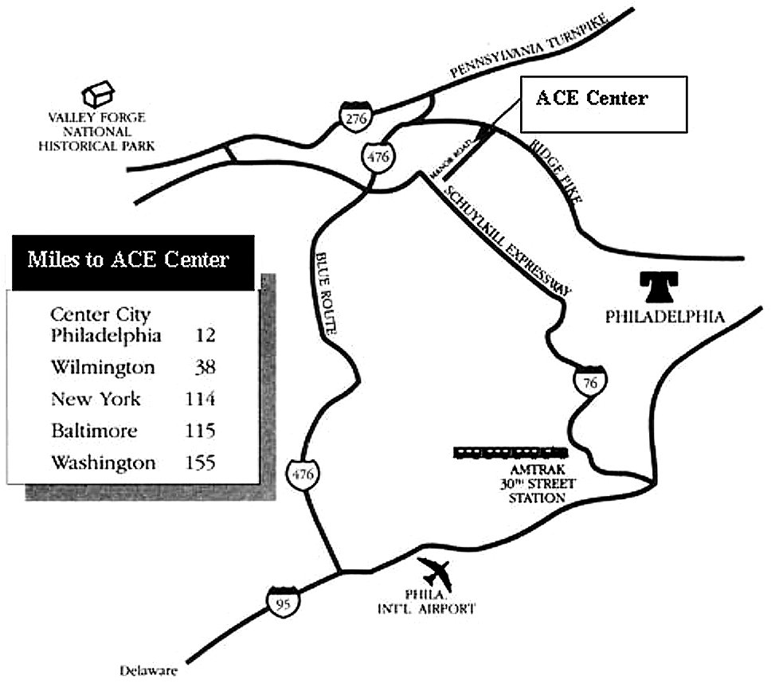
From Philadelphia International Airport: Take I-95 South to I- 476 North (Plymouth Meeting). Follow I-476 North for 18 miles to exit #18A Conshohocken. At end of ramp turn right onto Ridge Pike and proceed for 3.2 miles to the seventh traffic light at Manor Road. Turn right onto Manor Road. Proceed 200 yards and turn right into ACE Center.
From the South: Take I-95 North to I-476 North (Plymouth Meeting). Follow above directions.
From South Jersey: Take either the Walt Whitman or Ben Franklin Bridge to I-76 West (Schuykill Expressway toward Valley Forge). Go to I-476 North exit for Plymouth Meeting. Follow directions above from exit #18A to ACE Center.
From Norristown exit #333 Pennsylvania Turnpike (I-276): Bear right when exiting toll booth onto Germantown Pike (East). Proceed for 1.8 miles to third traffic light and turn right onto Joshua Road. At first traffic light turn left onto Ridge Pike and proceed for 1.5 miles to third light at Manor Road. Turn right and proceed 200 yards. Turn right into ACE Center.
From the North: Take Northeast Extension (I-476) South to East-West PA Turnpike (I-76 and I-276). Proceed West for 0.5 mile to Norristown exit #333. Follow above directions from toll booth.
From the West: Take the Pennsylvania Turnpike (I-276) to Norristown exit #333 (former exit 25). Follow above directions from toll booth.
By Car: 30 minutes from Philadelphia International Airport.
By Train: 20 minutes from Amtrak 30th Street station.

